PRESENTED B

Y: **GROUP 4 Members**

|  |  |
| --- | --- |
| ***NAME*** | ***MATRICULE*** |
| **DJEUTIO QUOIMON ANDERSON ROY** | FE21A169 |
| **MBUA SEDRICK GOBINA KOFI** | FE21A233 |
| **MBUNGAI GEORGE BERINYUY** | FE21A234 |
| **NJOH NOH PRINCE JUNIOR** | FE19A086 |
| **NOUPOUWO DONGMO STEPHANE MERCI** | FE21A283 |
| **POKAM NGOUFFO TANEKOU** | FE21A299 |
| **QUINUEL TABOT NDIP-AGBOR** | FE21A300 |
| **TIANI PEKINS EBIKA** | FE21A325 |
| **SINDZE DJAM ALAN WILFRED** | FE20A105 |

**FACILITATOR: DR NKEMENI VALERY**



**REPUBLIC OF CAMEROON**

**\*\*\*\*\*\*\*\*\*\*\*\*\*\***

**MINISTRY OF HIGHER EDUCATION**

**\*\*\*\*\*\*\*\*\*\***

**UNIVERSITY OF BUEA**

**\*\*\*\*\*\*\***

**FACULTY OF ENGINEERING AND**

**TECHNOLOGY**

**\*\*\*\*\***

**DEPARTMENT OF COMPUTER**

**ENGINEERING**

**REPUBLIQUE DU CAMEROUN**

**\*\*\*\*\*\*\*\*\*\*\*\*\*\***

**MINISTERE DE L’ENSEIGNEMENT**

**SUPERIEURE**

**\*\*\*\*\*\*\*\*\*\***

**UNIVERSITE DE BUEA**

**\*\*\*\*\*\*\***

**FACULTE D’INGENIEURIE ET DE**

**TECHNOLOGIE**

**\*\*\*\*\***

**DEPARTEMENT DU GENIE INFORMATIQUE**

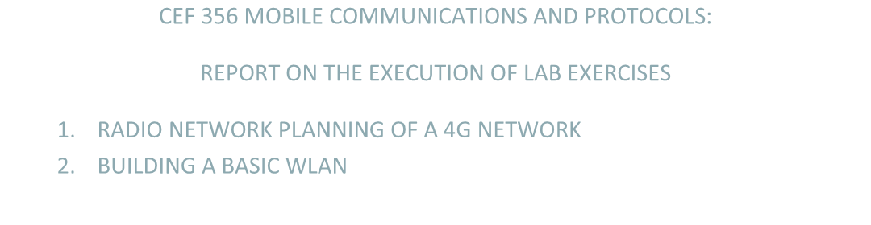

**CEF** **356**

**MOBILE COMMUNICATIONS AND PROTOCOLS:**

**REPORT ON THE EXECUTION OF L**

**LAB**

**EXERCISES**

**1**.

**RADIO NETWORK PLANNING OF A 4G NETWORK**

**2**.

**BUILDING A BASIC WLAN**

**LAB 1: RADIO NETWORK PLANNING OF A 4G NETWORK**

**INTODUCTION:**

Over the course of this semester we saw the different techniques involved in planning and setting up a radio network for mobile communication. In this report we shall discuss how we put this knowledge into practice.

**OBJECTIVE:**

Our objective is to perform coverage planning of a newly deployed LTE network in Atoll, a radio network planning software. Our case study here is the metropolitan area of Buea in the South West Region of Cameroon.Our exercise will consist in determining the minimum number of BTS sites that will provide us with the best coverage possible.

**AIM**: Coverage planning of LTE network in Atoll, case study Buea area.

**HARDWARE AND SOFTWARE REQUIREMENTS:**

* Personal computer
* Atoll, Google Maps and Google Earth

**PROCEDURE:**

First and foremost, before the actual deployment of the BTS on the field we had to plan their position. This is done with the help of Geospatial Information Systems (GIS) like Google Earth. To do this Google earth was started on our PC with a working internet connection. This is done in this way so that we can have an updated layout of the terrain which we want to work with. When that was done, we could see a window like the one below :

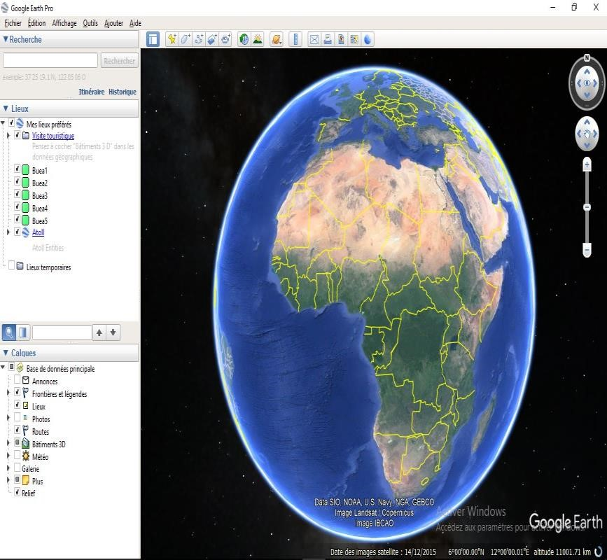

Once that was done we search Buea in the search panel on the top left corner of the window

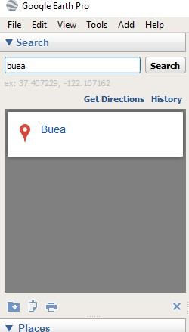

From here we had to mark out the desired areas for our planning. But before that we had to import the Buea map from google maps to google earth so as to avoid placing our BTSs out of Buea. The diagram below shows a drawing of the Buea boundaries and it’s total surface area on google maps.

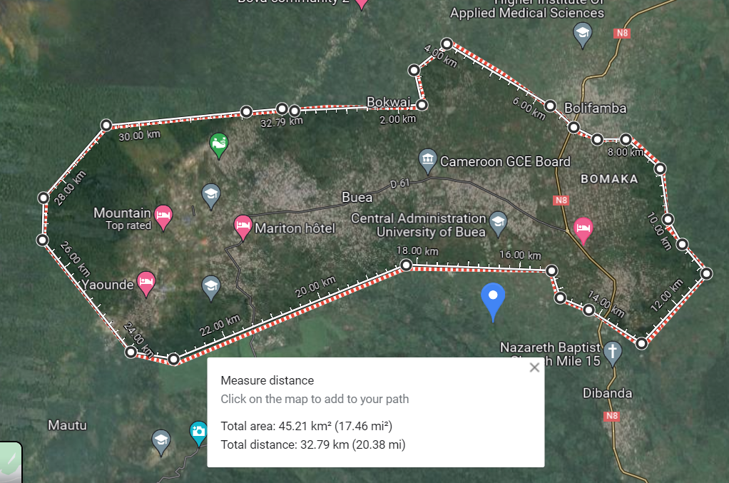

When this was done, we used place markers and noted down the location details (place marker name, longitude and latitude) in an excel sheet. Below you can observe the diagram of our coordinates on google earth and in our excel sheet.

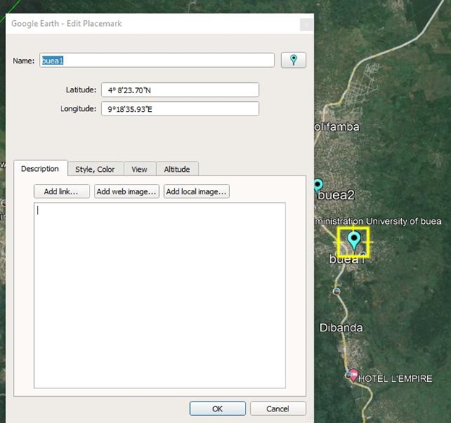

Excel sheet containing our respective coordinates

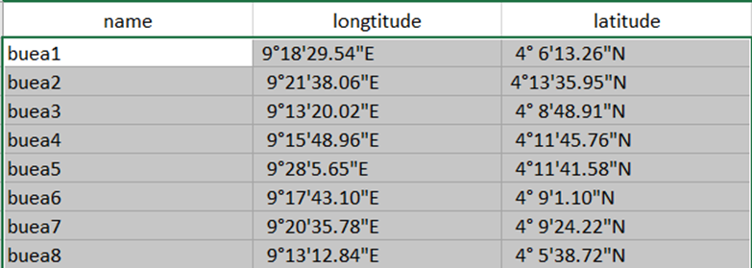

From here on out we are ready to export this plan to Atoll for the planning proper.

After we have correctly launched the atoll software and selected the correct time zones and coordinate systems for our project, we are ready to copy paste our coordinates recorded in the excel sheet to our sites table on Atoll.

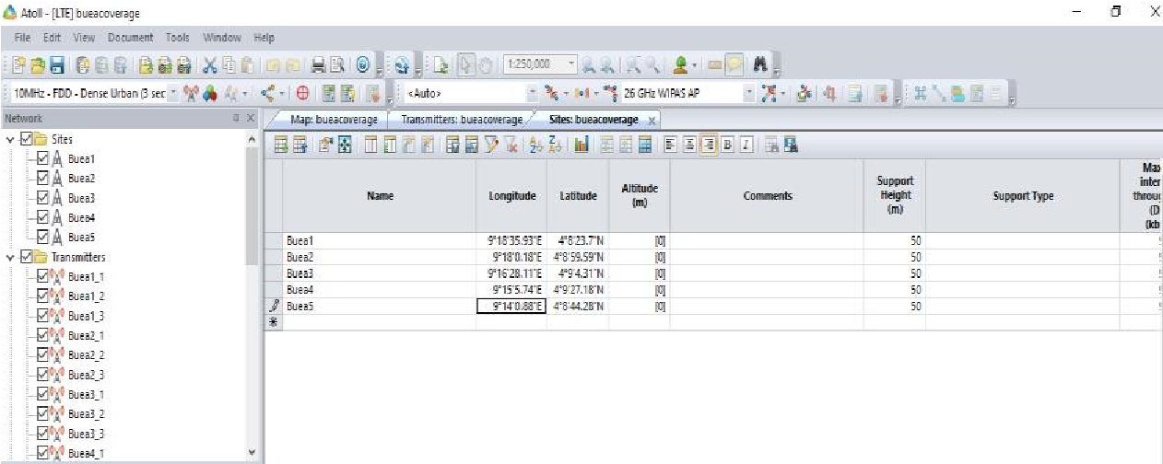

Before, continuing this project on Atoll, the following calculations were considered and implemented in this project:

Total surface area of Buea from Google Maps (AT) = 45.21 ${km}^{2}$

Radius of 1 cell from Atoll (R) = 1.6 km

Knowing that the Area of a cell is given by : $\frac{3√3}{2}R^{2}$

* $\frac{3√3}{2}{(1.6 km)}^{2}$ = 6.7 ${km}^{2}$

Therefore we derived that the total number of cells required is : $\frac{Total Surface Area (AT) }{Area of a cell (R)}$

* : $\frac{45.21{km}^{2}}{6.7 {km}^{2}}$ = 6.7 cells $⇋$ 7 cells

This implies that a total of 7 cells were used for planning of the 4G network.

For each of these sites which in practice represent the location of our BTS we will add 3 antennas, to utilize the concept of **Sectoring** which will allow us to have a better coverage and signal quality. In this case, we will use 65deg 18dBi 4Tilt 2100MHz antennas.

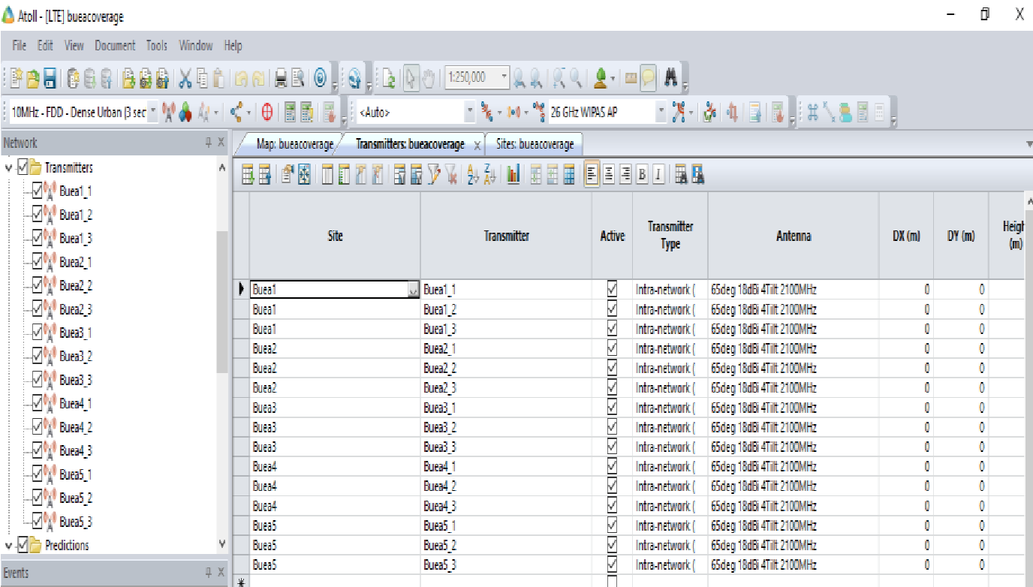

We then manually set the mechanical azimuth of each of the transmitters to 0°, 120° and 240° each

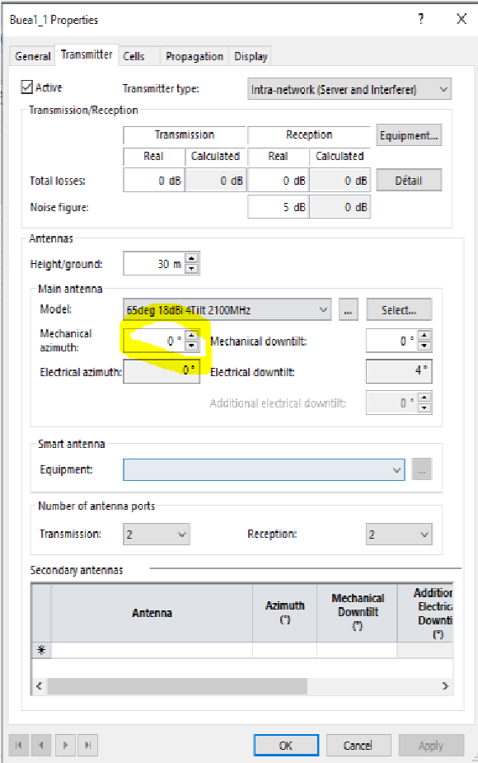 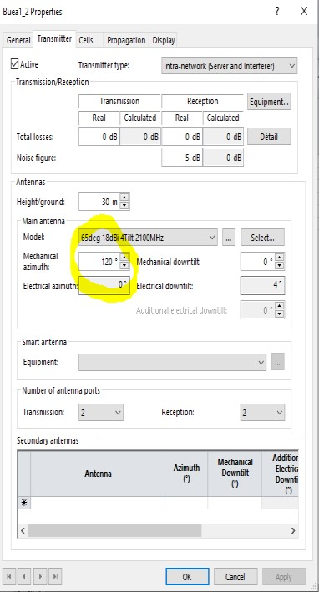 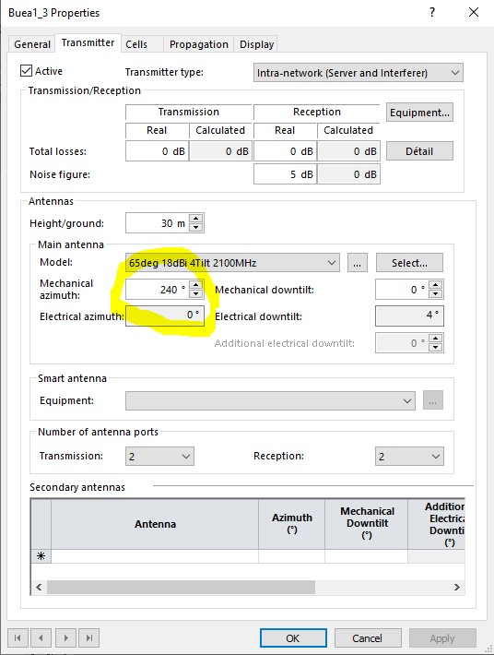

This done we proceed to calculate the predicted signal coverage level. This is done after setting our predictions to **Coverage by Signal Levels (DL)**

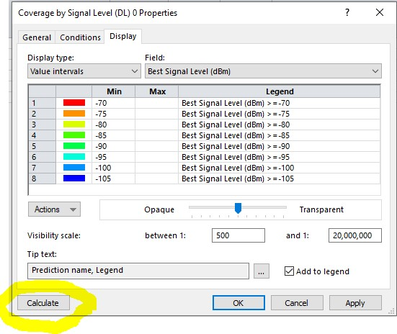

After this done, we can export our prediction to our favourite GIS (in our case Google Earth). Hence we obtain the following image.

**Diagram from google earth**

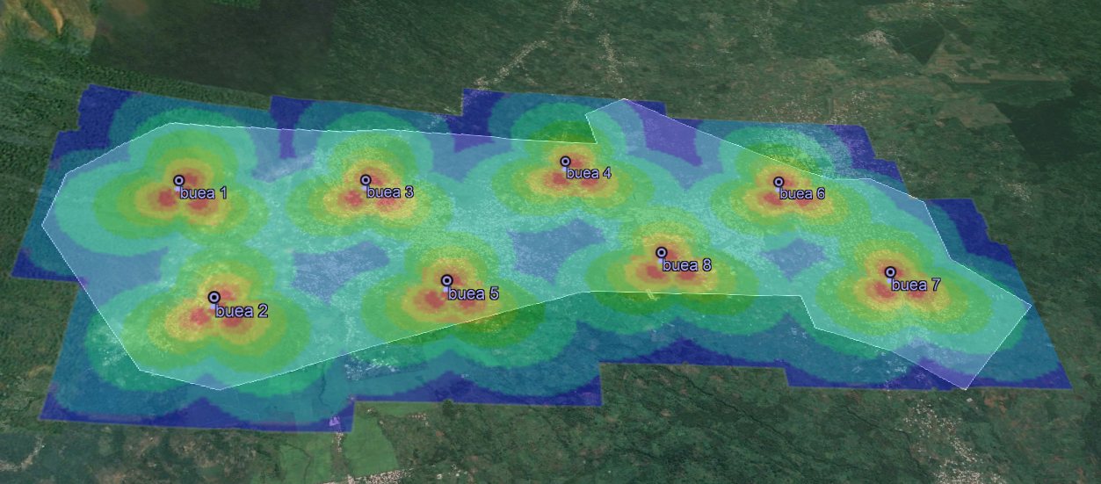

The colours represent the signal level with respect to the BTS from which it is emitted, the red region being the area of greater intensity and the blue regions those of weak signal levels. The following chart represents the mapping of signal level (in Decibels) to the different colours.

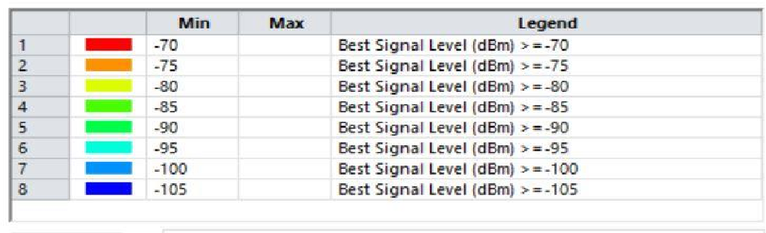

**OBSERVATION:**

We notice from the from the prediction that to effectively give the optimal network coverage to all zones we will need to use more BTS which will also give permit us to have more subscribers. So, as the town grows and expands to actually uninhabited zones further planning will need to be done.

**CONCLUSION:**

This procedure produced a good layout plan for a radio network planning of a 4G LTE network in the town of Buea and with more research and investigation more improvements could yield better results.

**THANK YOU**

**PROJECT 2: WLAN SERVICE CONFIGURATION TO CONNECT THE FET BUILDING AND THE TECHNOLOGY BUILDNG**

**AIM:**

Configure a WLAN to connect FET building and technological building

**OBJECTIVE:**

Our exercise will consist on the configuration of WLAN services to connect the FET Building and the technological building in Ensp.

**REASONING:**

For the distribution of the Aps, we decided to use an AP at FET building and another at the technological bulding for devices in both location to be able to communicate together

**DEVICE SPECIFICATIONS:**

• An AC: AC6005

• Applicable Aps: AP2050

• Switches: S5700

• Stations: STAs …etc.

**TOPOLOGY:**

We implemented the WLAN using the tree topology as shown below

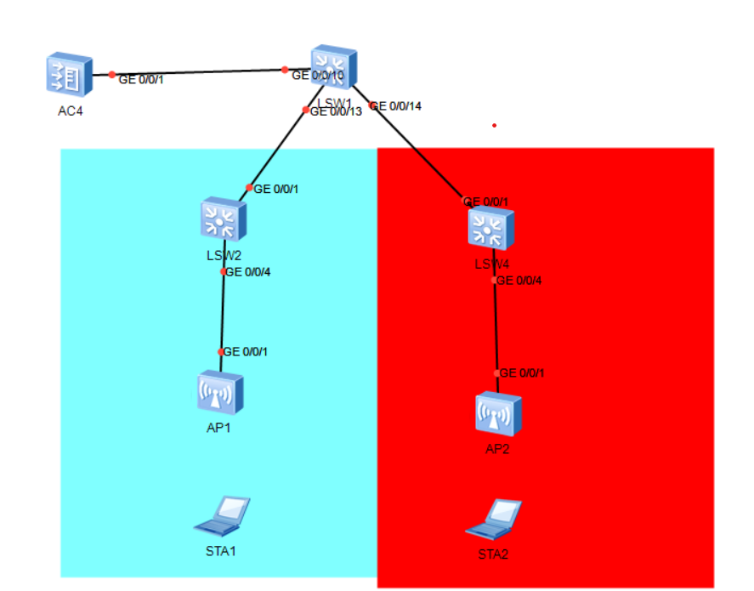

1. The AC is deployed in an out-of-path mode and is on the same layer 2 network as the Aps. Meaning that data is not going to pass through the AC and the Aps will learn about the AC using the broadcast mode.

2. The AC functions as a DHCP server to assign IP addresses to Aps and S1 functions as a DHCP server to assign IP addresses to stations.

3. Service data is directly forwarded.

**REQUIREMENT ANALYSIS:**

|  |  |
| --- | --- |
| I tem | Configuration |
| AP management VLAN | VLAN 100 |
| Service VLAN | VLAN101 |
| DHCP Server | - AC functions as a DHCP server to allocate IP addresses to Aps.  - S1 functions as a DHCP server to allocate IP addresses to stations. |
| I P address pool for APs | 192.168.100.1 - 192.168.100.253/24 |
| IP address pool for STAs | 192.168.101.1 - 192.168.101.253/24 |
| IP address of the AC's source interface | VLANIF100 : 192.168.100.254/24 |
| AP group | - Name: ap-group1  - Referenced profiles: VAP profile HCIA-WLAN and regulatory domain profile default |
| Regulatory domain profile | - Name : default  - Country code : CN |
| SSID profile | - Name: HCIA-WLAN  - SSID name: HCIA-WLAN |
| Security profile | - Name: HCIA-WLAN  - Security policy: WPA-WPA2+PSK+AES - Password: HCIA-Datacom |
| VAP profile | - Name: HCIA-WLAN  - Forwarding mode: direct forwarding  - Service VLAN : VLAN 101  - Referenced profiles: SSID profile HCIA-WLAN and security profile HCIA-WLAN |

* Two VLANS were implemented: VLAN 100 for the Aps and VLAN 101 for the Stations
* All physical link will be trunk
* The ip address : 192.168.100.254/24 is the ip address used by the Aps to communicate with the AC
* The ip address 192.168.101.254 is used as the gateway for the stations
* An ap-group named ap-group1 is created
* Also, a regulatory profile with the name default and country code CN is created
* An SSID profile with name HCIA-WLAN and SSID name HCIA-WLAN is created
* A security profile with name HCIA-WLAN with security policy WPA-WPA2+PSK+AES and password HCIA-Datacom is created.

Finally a VAP profile which bounds all the profiles we have created with service VLAN 101 in the direct forwarding name

**IMPLEMENTATION ROADMAP:**

1. Configure the connectivity of the wired network.

2. Configure the APs and bring them online.

• Create AP groups and add APs of the same configuration to the same group for unified configuration.

• Configure AC system parameters, including the country code and source interface used by the AC to communicate with the APs.

• Configure the AP authentication mode and import the APs to bring them online.

3. Configure WLAN service parameters and deliver them to APs for STAs to access the WLAN.

**PROCEDURE:**

**Step 1**: Name the devices using the command “syaname name_of_device” in the system view

**Step 2**: Configure the wired network.

• **Configure VLANs**.

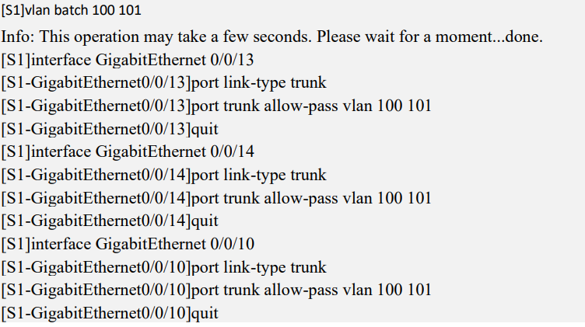

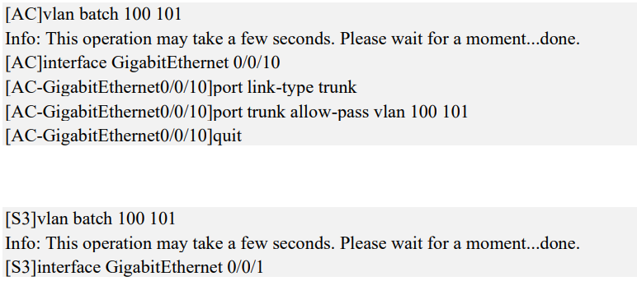

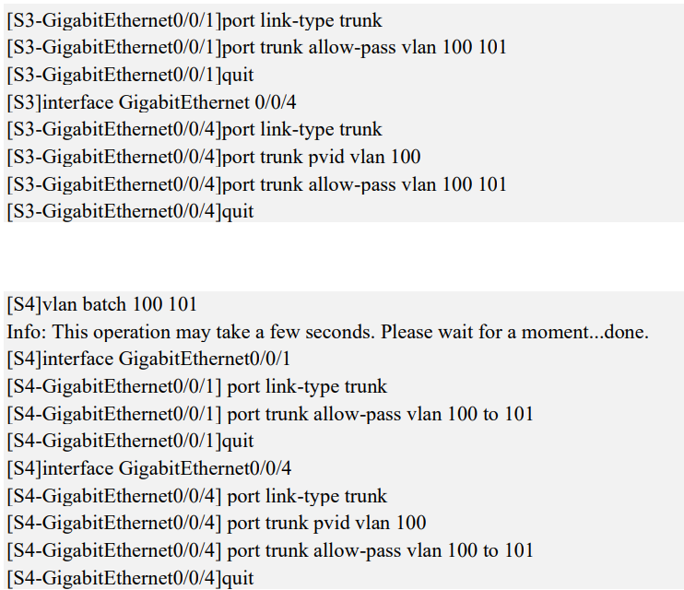

Here we configure each interface as trunk and allow vlan 100 and 101

Interface GE0/0/4 of S2 and S3 is configured with pvid of 100

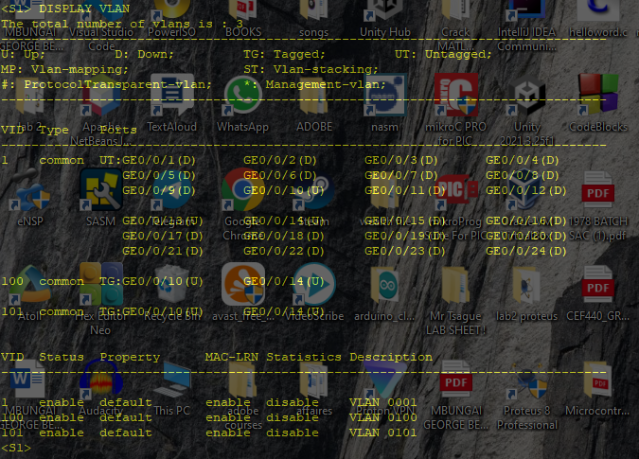

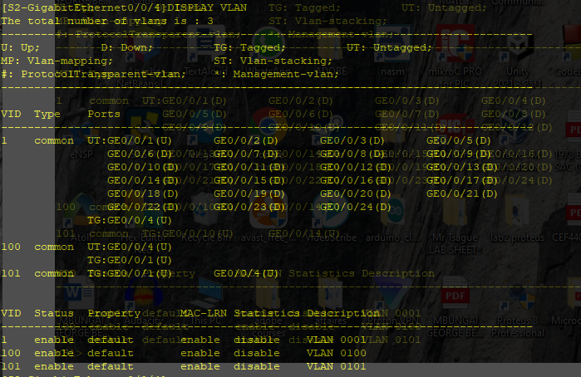

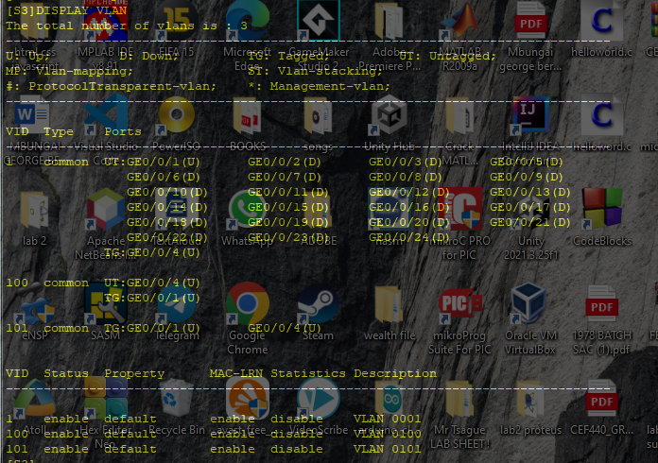

**• Configure interface IP addresses**

Here we configure Vlan interfaces 101 on S1 and 100 on AC and assign ip address to the interfaces. The loopback interface is used to test if devices can connect to the internet

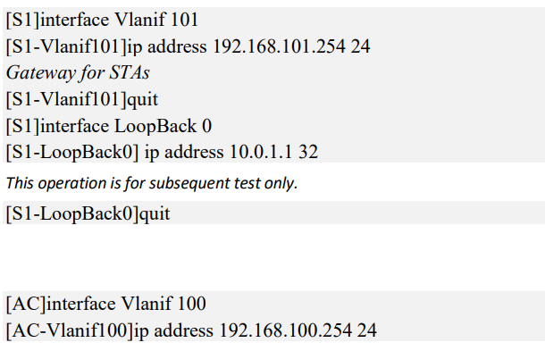

• **Configure DHCP**

Configure S1 as DHCP for stations and name it ip pool sta then give it a network address and specify the gateway as the Vlanif that we just created and enable the vlan interface

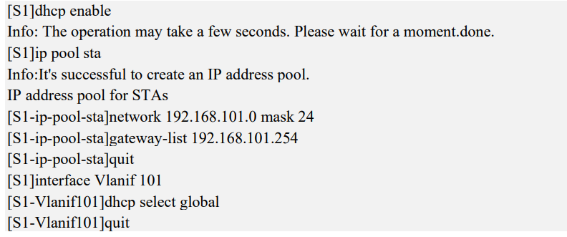

Configure AC as DHCP for APs and name it “ip pool ap” then give it a network address and specify the gateway as the Vlanif that we just created and enable the vlan interface

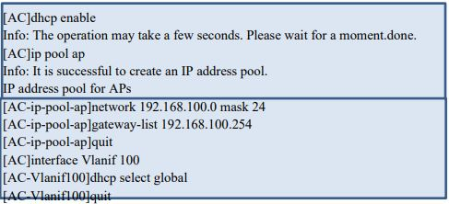

**Step 3:** Configure the APs to bring them online.

• **Create an AP group and name it ap-group1.**

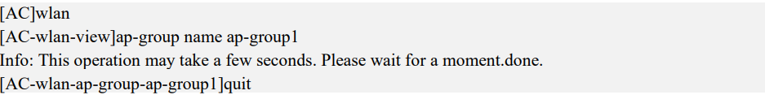

**• Create a regulatory domain profile with the name: default, and set the AC country code in the profile as the default country code CN**

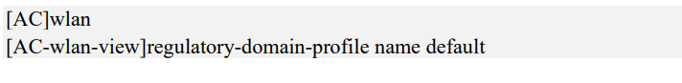

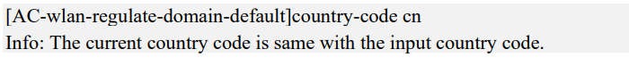

**• Bind the regulatory domain profile to the AP groups we just created.**

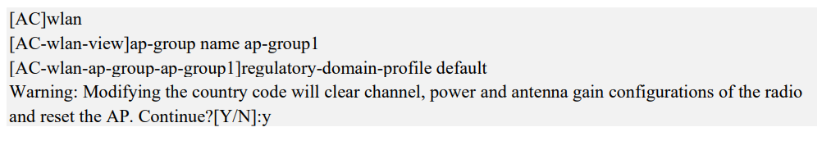

**• Specify a source interface(address) on the AC for establishing CAPWAP tunnels. In our case it will use the ip address of vlan 100 as the source address of the CAPWAP interface**



**• Import Aps to the AC and add the Aps to AP group ap-group1using manual configurations but specifying the MAC address of the Aps and add the AP to the ap-group1(for both APs)**

To know the MAC address of an AP, you go on the ap and “display system information”

• Display the information about the current AP(in the wlan view)

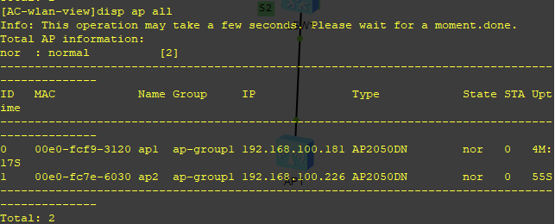

**Step 4:** Configure WLAN service parameters.

• A security profile HCIA-WLAN is created and a security policy is configured.



Wpa or wpa2 is used for authentication of terminals, a preshared key(HCIA-Datacom) is used and the encryption algorithm for user traffic is aes

• AN SSID profile is created and the SSID name set to HCIA-WLAN.

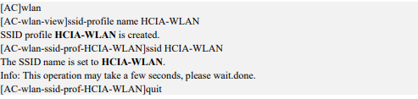

• A VAP profile HCIA-WLAN is created, a data forwarding mode is configured to direct-fowarding and service VLAN are configured with the vlan-id 101, and the security and SSID profiles are applied to the VAP profile.

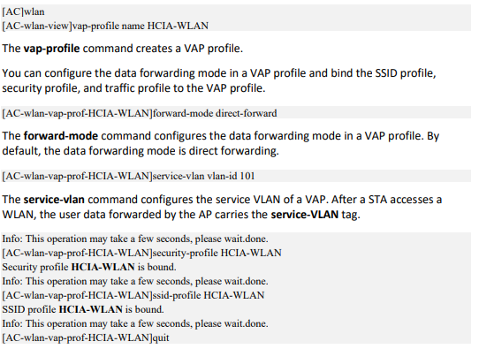





• The VAP profile is bound to the AP groups and the configurations in VAP profile HCID-WLAN are applied to radio 0 and radio 1 of the Aps in the AP groups. All configurations of the AP group

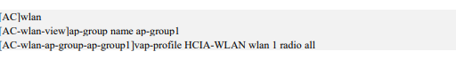

**RESULT**

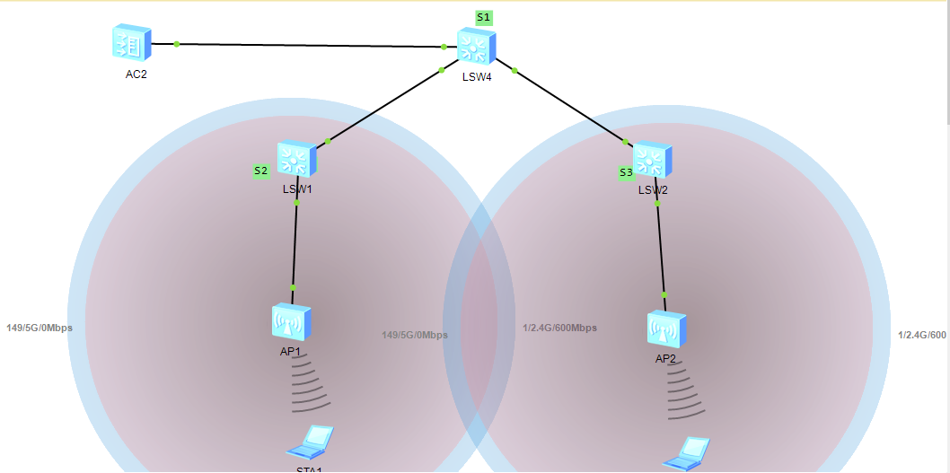

**TESTING THE SYSTEM**

* The STAs were used to access the WLAN with the SSID of HCIA-WLAN.

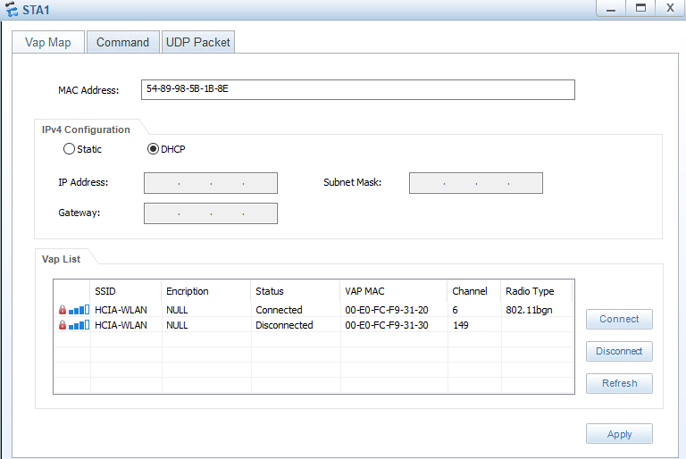

* The ip address of the STA is checked

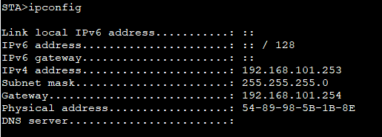

* The STA is used to ping the loopback interface to determine if the devices can connect to the internet

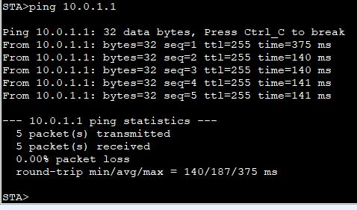

* The devices connected are displayed from the AC

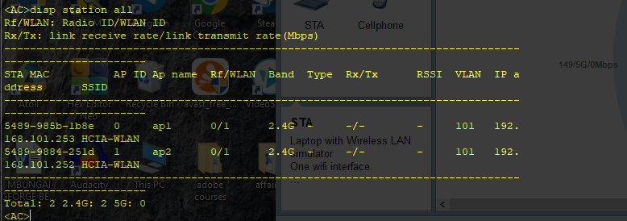

**CONCLUSION:**

In a WLAN the end devices are able to connect wirelessly to the network. When coupled with a VLAN protocols we are able to separate these devices and restrict them to particular levels of access depending on our network requirements and constraints.

After the design and configuration of the WLAN, an access station can be installed at FET building and another at technological building so that devices in each location can connect to the access and share layer 2 frames. Devices in separate buildings can communicate passing through S1

**THANK YOU**